MONOFIA UNIVIRSTY  SYSTEM ANALSIS DESIGN PROJECT  SECOUND YEAR  2026\2027 | جامعة المنوفية  كلية الحاسبات والمعلومات  2026\2027

Carpool Scheduling and Payments System
No | Name | section
1- | Rawda salah Abdelhamid Abdelmawla | 1

PIANNING(project plan)

.

Project Identification
Project name:
Carpool Scheduling and Payments System
Current problem:
1- Difficulty in coordinating rides between drivers and passengers manually.
2- Lack of a reliable and secure payment mechanism for sharing trip costs.
3- Inefficient scheduling, leading to empty car seats and higher individual transportation costs.
4- Inability for passengers to track ride schedules, driver details, or booking statuses in real time.
Description about project:-

The system provides an automated platform to manage carpooling and ride-sharing efficiently. It enables drivers to schedule trips, set available seats, and define prices per seat. Passengers can easily search for available rides, book seats, and complete payments online. For system administrators, it simplifies driver and vehicle verification, payment tracking, and report generation accurately and without manual errors.

System Request
System Request - Carpool Scheduling and Payments System
Project sponsor: | Rawda
Business Need: | 1- Automate ride scheduling, passenger matching, and fare estimation.  2-Eliminate manual coordination and paper-based tracking of rides.  3-Track trip payments, passenger bookings, and driver availability in real-time.  4-Provide quick access to driver, passenger, and trip details.
Business Requirement: | 1- ​Database system for managing passengers, drivers, routes, and vehicles.  ​2-Search and query interface for trip schedules, pickup locations, and available seats.  ​3-Payment and fare calculation tracking module.  ​4-Report generation for ride statistics, fuel-cost sharing, and trip history.
Business Value: | 1- ​Saving time and effort when booking or offering daily commutes.  ​2-Reducing scheduling errors, double-booking seats, and route miscommunications.  ​3-Improving operational and travel efficiency.  ​4-Saving transportation costs and reducing carbon footprint/traffic congestion.
Special Issus or constrains: | 1- ​Deadline: End of the current semester.  ​2-High data privacy and security requirements for user profiles, location data, and payment records.

Feasibility Analysis
Technical Feasibility:-
​1- We need to design the database using Microsoft Access / MySQL.
2-We need some development tools and applications like Microsoft Access, MySQL Workbench, or NetBeans.
3-We need to make it work on an internal local network (LAN) or online when connected to the server/internet.
4-We need to make this system run on standard operating systems like Windows.
Economic Feasibility:-
​1- The benefit of this project will be high by automating ride scheduling, driver/passenger matching, and payment tracking.
2-The operational costs will be minimal since open-source or existing database software is utilized.
3-The system reduces financial risk by accurately tracking trip fares, splitting costs, and preventing manual calculation errors.
4-The cost of developing and maintaining the database system will not be high.
Organizational Feasibility:-
Organizational Feasibility Analysis includes the assessment of:
​1- Management prowess: What is the ability of the system administration and technical team to manage and operate the new carpool system effectively?
2-Resource sufficiency: What nonfinancial resources such as human resources (system admins, support staff), facilities, equipment (computers and network access), and data privacy policies are required?

Time Estimation

 | planning | Analysis | Design | implementation
Standard percentage | 15% | 20% | 35% | 30%
Estimated time based on planning time | Acual:11days | 15days | 25days | 22days

Tasks Identification
Name of Task | System Request
StartDate | 1\10\2026
End Date | 15\10\2026
Person assigned to task | Rawda
Priority | High
Resources Needed | Microsoft word
Estimated Time | 4hours
Actual Time | 2hours

Name of Task | Feasibility Study
StartDate | 16\10\2026
End Date | 20\10\2026
Person assigned to task | Marwa
Priority | High
Resources Needed | Microsoft word
Estimated Time | 6 hours
Actual Time | 8 hours

Name of Task | Pert Chart , Grant Chart
Start Date | 26\10\2026
End Date | 30\10\2026
Person assigned to task | Dalia
Priority | High
Resources Needed | Microsoft word
Estimated Time | 5 hours
Actual Time | 9 hours

Name of Task | Interview
Start Date | 1\11\2026
End Date | 5\11\2026
Person assigned to task | AHMED , Rawda
Priority | medium
Resources Needed | Microsoft word
Estimated Time | 10 hours
Actual Time | 11 hours

Name of Task | Questionnaire
Start Date | 7\11\2026
End Date | 10\11\2026
Person assigned to task | Rofaida
Priority | medium
Resources Needed | Microsoft word
Estimated Time | 16 hours
Actual Time | 20 hours

Name of Task | Data Flow Diagram
Start Date | 11\11\2026
End Date | 15\11\2026
Person assigned to task | Reem
Priority | High
Resources Needed | Microsoft word
Estimated Time | 5 DAYS
Actual Time | 7days

Name of Task | Data Store
Start Date | 18\11\2026
End Date | 26\11\2026
Person assigned to task | Rawan
Priority | High
Resources Needed | Microsoft word
Estimated Time | 7days
Actual Time | 9 days

Name of Task | Process specification
Start Date | 27\11\2026
End Date | 30\11\2026
Person assigned to task | Nouran
Priority | High
Resources Needed | Microsoft word
Estimated Time | 10 days
Actual Time | 11 days

Name of Task | Entity Relationship
Start Date | 1-12-2026
End Date | 12\12\2026
Person assigned to task | Abdallah Hany
Priority | High
Resources Needed | Microsoft word
Estimated Time | 15 days
Actual Time | 19 days

Name of Task | Normalization
Start Date | 15\12\2026
End Date | 25\12\2026
Person assigned to task | Ahmed salah
Priority | High
Resources Needed | Microsoft word
Estimated Time | 14 days
Actual Time | 18 days

Name of Task | design
Start Date | 26\12\2026
End Date | 1\1\2027
Person assigned to task | _
Priority | High
Resources Needed | Microsoft word
Estimated Time | 13 days
Actual Time | 16 days

Name of Task | Implementation
Start Date | 2\1\2027
End Date | 12\1\2027
Person assigned to task | Rawda , Marwa
Priority | High
Resources Needed | Microsoft word
Estimated Time | 18 days
Actual Time | 19 days

Pert Chart (MS-Project)
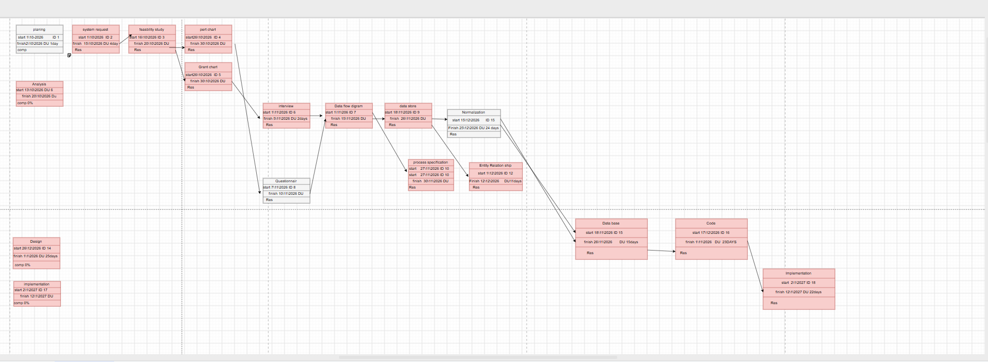

Gantt chart (MS-Project)
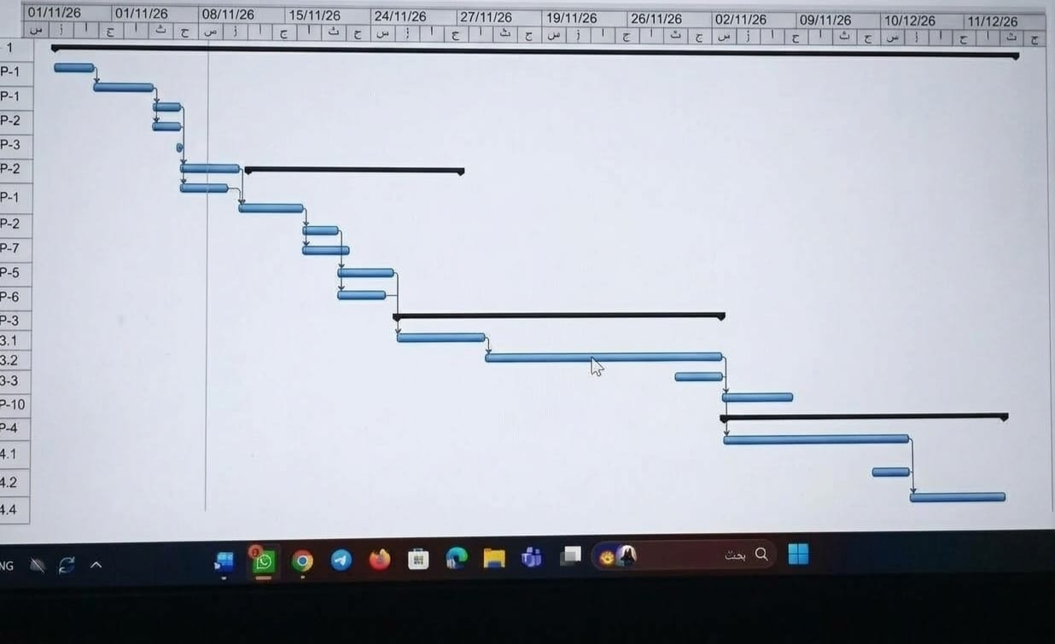

Analysis (project proposal)

Interview
(include questions and answers )
1- What's your opinion of the current state of your business?
I think it's challenging due to manual scheduling and payment tracking.
​2- Is the system easy to use?
Yes, the system is simple and user-friendly.
​3- How does the system look like or work?
The system is a platform that allows commuters to find available carpool rides easily by selecting their destination or departure time. It enables drivers to publish their routes and passengers to book seats and split ride costs digitally. The system automatically calculates fares based on distance, tracks active trips in real-time, and securely processes payments. It reduces travel expenses, minimizes traffic congestion, and saves time without manual coordination.
​4- What are the common errors your system have?
Inaccurate location tracking and payment processing delays.
​5- What are the critical objectives of your system?
​Critical objectives of my system
​Facilitate affordable commuting
​Ease of use for drivers and passengers
​Secure and automated fare payment
​Efficient route matching and scheduling
​6- What technologies you use now in your current system?
Web and mobile development tools, GPS mapping integration, and online payment gateway services.
​7- Who are the main users of your system?
Daily commuters, university students, and drivers looking to share fuel costs.
​8- How does the system secure user data and payments?
By using encrypted communication protocols and secure payment gateway verification.
​9- What features are planned to improve the system in the future?
Adding live driver tracking, emergency safety buttons, and route optimization.
​10- How does the system handle booking cancellations?
It automatically refunds the payment based on the cancellation policy and notifies the driver immediately.
​

Interview Reports
Interview Report
Person Interviewed: Eng Mohamed

Interviewer: Rawda

Purpose of Interview:

1-To see how the system works with it

2-Take advantage of its system and address errors

3-Knowing some of the system tools and how they will be developed

Summary of Interview:

-The system is a platform for ride sharing and automated fare payments.

-Common error is inaccurate location tracking and payment processing delays.

-Use encrypted protocols and secure payment gateway services.

Open Items:

1- Minimum 2 system admins to monitor active rides and payment logs.
2- Create a mobile application to make the ride booking and payment process fast for commuters.
3- Create a web page to make managing schedules and fare rules easy for the admin.
-Detailed Notes: See attached transcript.

Interview Reports

Interview Report
Person Interviewed: Eng Ahmed

Interviewer: Rawda

​Purpose of Interview:

​1-To see how the system works with it

​2-Take advantage of its system and address errors

​3-Knowing some of the system tools and how they will be developed

​Summary of Interview:

​-The system provides dynamic route searching and automatic seat availability updates.
​-Common error is route mismatch during peak traffic hours and sudden ride cancellations.
​-Use GPS mapping integration and automated SMS/push notifications.
​Open Items:

​1- Minimum 3 verification steps for new driver profiles and vehicle documents.
​2- Create a mobile application feature for real-time driver tracking and arrival alerts.
​3- Create a web dashboard page for managing driver subscriptions and payout schedules.
​-Detailed Notes: See attached transcript.

Interview Reports
Interview Report
Person Interviewed: Eng Sara

Interviewer: Rawda

​Purpose of Interview:

​1-To see how the system works with it

​2-Take advantage of its system and address errors

​3-Knowing some of the system tools and how they will be developed

​Summary of Interview:

-​The system manages passenger seat bookings, trip histories, and electronic receipts.

​-Common error is payment gateway timeout and double booking issues during poor connectivity.

​-Use offline data caching and automated refund processing engines.
​Open Items:

​1- Minimum 2 payment options (Credit/Debit Card and Digital E-Wallets).
​2- Create a mobile application module for quick fare splitting and instant refunds.
​3- Create a website page for user support, ride history receipts, and feedback ratings.
​-Detailed Notes: See attached transcript.

Questionnaire & RESPONSES
(using Google Forms, you must include questions and statistics)

https://docs.google.com/forms/d/e/1FAIpQLSdIXj9M-XoJsZHVHQEL9Of1z2pn6lGH1i-7AwXOYRAetlabUw/viewform?usp=header
